PROJECT PHASE -1(410248)
REPORT ON
“NUTRIFY: FITNESS DATA ANALYSIS USING MACHINE LEARNING”

SUBMITTED TO THE SAVITRIBAI PHULE PUNE UNIVERSITY, PUNE IN THE PARTIAL FULFILLMENT OF THE REQUIREMENTS
FOR THE AWARD OF THE DEGREE OF

BACHELOR OF ENGINEERING
(COMPUTER ENGINEERING)

SUBMITTED BY

KHETMALIS VINAYAK SURYAKANT 14231
ADAGALE ABHISHEK DATTU 14201
GADEKAR AJINKYA SANTOSH 14216
DESHMUKH AVINASH HANMANT 14211


Under The Guidance of
Prof. Anita Shinkar
DEPARTMENT OF COMPUTER ENGINEERING
DR. D. Y. PATIL COLLEGE OF ENGINEERING AND INNOVATION, VARALE, PUNE

SAVITRIBAI PHULE PUNE UNIVERSITY
2023-24


DR. D. Y. PATIL COLLEGE OF ENGINEERING
AND INNOVATION, VARALE

SAVITRIBAI PHULE PUNE UNIVERSITY, PUNE

CERTIFICATE

This is to certify that the project report entitles

“NUTRIFY: FITNESS DATA ANALYSIS USING MACHINE LEARNING”

Submitted by

KHETMALIS VINAYAK SURYAKANT 14231
ADAGALE ABHISHEK DATTU 14201
GADEKAR AJINKYA SANTOSH 14216
DESHMUKH AVINASH HANMANT 14211

are bonafide students of this institute and the work has been carried out by them under the supervision of Prof. Anita Shinkar and it is approved for the partial fulfillment of the requirement of Savitribai Phule Pune University, for the award of the degree of Bachelor of Engineering (Computer Engineering).
Place: Talegaon
Date : / /2023

PROF.ANITA SHINKAR | DR. DEEPALI R. SALE
PROJECT GUIDE | PROJECT CO-ORDINATOR
DR. ALPANA P. ADSUL | DR. SURESH. N. MALI
HOD, DEPT. OF COMPUTER ENGG. | PRINCIPAL, DYPCOEI
EXTERNAL EXAMINER

ACKNOWLEDGEMENT

We express our gratitude to my guide Dr. Deepali Sale for her competent guidance and timely inspiration. It is our good fortune to complete our Project under her able competent guidance. This valuable guidance, suggestions, helpful constructive criticism, keeps interest in the problem during the course of presenting this “NUTRIFY: FITNESS DATA ANALYSIS USING MACHINE LEARNING” project successfully
We would like to thank our Project Guide Prof. Anita Shinkar and Project Coordinator Dr. Deepali Sale for her continuous help and valuable guidance.
We are very much thankful to Dr. Alpana Adsul, Head, Department of Computer Engineering and also Dr. Suresh Mali, Principal, Dr. D. Y. Patil college of Engineering & Innovation, Varale, Talegaon for their unflinching help, support and co- operation during this project work.
We would also like to thank the DYPCOEI Technical Educational Society for providing access to the institutional facilities for our project work.

THANKING TO ALL OF YOU…

Mr. KHETMALIS VINAYAK SURYAKANT
Mr. ADAGALE ABHISHEK DATTU
Mr. GADEKAR AJINKYA SANTOSH
Mr. DESHMUKH AVINASH HANMANT

ABSTRACT

Nutrify is an era of rapid technological advancement, the integration of IoT sensors into small fitness wearables marks a paradigm shift in personalized health and nutrition monitoring. These diminutive yet potent sensors have transcended their conventional roles, now encompassing an extensive array of health metrics, including skin temperature and blood oxygen levels, delivering real-time, granular insights. This wealth of data is processed through sophisticated machine learning and AI algorithms, uncovering intricate health patterns and proactively predicting potential issues while offering highly individualized dietary recommendations. Simultaneously, the formidable capabilities of big data analytics and data science are leveraged to navigate the vast datasets generated, providing a holistic understanding of the multifaceted factors influencing health. This holistic approach not only fuels the creation of predictive models but also empowers timely interventions for preventive healthcare. Acknowledging the importance of ethics in this data-rich landscape, considerations regarding health data privacy and security are scrutinized. In summation, this review underscores the transformative potential of IoT sensor integration within small fitness wearables, granting individuals the means to take charge of their health and make informed dietary choices, ultimately paving the way for a healthier future.

Keywords –Machine Learning, Fitness, Health, Data Analytics, Nutrition, Android Fitness app, CMM, IOT, Fitness Wearables.

INDEX
1. Introduction 7
1.1 Overview: 7
1.2 Motivation: 8
1.3 Problem Definition and Objectives: 8
1.4 Project Scope & Limitations: 9
1.5 Methodologies of Problem Solving: 10
2. Literature Survey 12
3. Software Requirements Specification 13
3.1 Functional Requirements: 13
3.2 Non-Functional Requirements 13
4. System Design 15
4.1 System Architecture 15
4.2 Use Case Diagram: 16
5. Implementation ………………………………………………………………………………………….17

6. Output…………………………………………………………………………………………..21
7.Conclusion 25
8.Future Scope 25
9. References 26

LIST OF ABBREVATIONS

ABBREVIATION | ILLUSTRATION
ROAMM | Real-Time Online Assessment and Mobility Monitoring
CMM | Cognitive Mediation Model
APP | Application
EHRs | Electronic Health Record System
HR | Health Record
UML | Unified Model Diagram
QEA | Quantum-inspired Evolutionary Algorithm
MAABS | Multiple Authority-Based Signature
ABS | Attribute Based Signature

- INTRODUCTION

Nutrify is an era of rapid technological advancement, the integration of IoT sensors into small fitness wearables marks a paradigm shift in personalized health and nutrition monitoring. These diminutive yet potent sensors have transcended their conventional roles, now encompassing an extensive array of health metrics, including skin temperature and blood oxygen levels, delivering real-time, granular insights. This wealth of data is processed through sophisticated machine learning and AI algorithms, uncovering intricate health patterns and proactively predicting potential issues while offering highly individualized dietary recommendations. Simultaneously, the formidable capabilities of big data analytics and data science are leveraged to navigate the vast datasets generated, providing a holistic understanding of the multifaceted factors influencing health. This holistic approach not only fuels the creation of predictive models but also empowers timely interventions for preventive healthcare. Acknowledging the importance of ethics in this data-rich landscape, considerations regarding health data privacy and security are scrutinized. In summation, this review underscores the transformative potential of IoT sensor integration within small fitness wearables, granting individuals the means to take charge of their health and make informed dietary choices, ultimately paving the way for a healthier future.

  - Overview

In a world where health and wellness are of paramount concern, this project endeavors to meet the surging demand for personalized fitness and well-being solutions. Through the development of an innovative Android application, the project aims to harmoniously integrate IoT wearables, machine learning algorithms, and user-provided data. This synergy enables real-time monitoring of fitness metrics, offering insightful feedback during workouts. Users can create and manage personalized fitness profiles, tailored to their individual factors and goals. The app will also provide guided workouts suitable for various fitness levels and incorporate safety assurance measures by monitoring equipment conditions. This comprehensive approach, underpinned by data-driven insights and user-friendly interfaces, aims to revolutionize the way individuals engage with their health and fitness, ultimately paving the way for a healthier and more informed future.

  - Motivation

The project aims to develop a cutting-edge Android fitness app that leverages IoT wearables and data analytics to provide users with an array of benefits, including real-time monitoring during workouts, tailored guidance for individuals of all fitness levels, seamless team coordination, personalized workouts, sustained motivation through gamification, safety assurance, and in-depth insights into health and fitness. This holistic approach empowers users to make informed decisions about their fitness and well-being, enhancing their overall health and quality of life.

  - Problem Definition and Objective
Problem Definition:

The project addresses the challenge of effective fitness data analysis and maintaining personalized fitness profiles through a seamless Android application interface. The problem is rooted in the overwhelming volume of fitness data generated by wearables, coupled with the need for users to input relevant information. These issues result in unutilized potential, as data remains unprocessed and profiles lack individualization. The project aims to leverage machine learning for data analysis, integrate data from fitness wearables and user-defined inputs, and provide a user-friendly interface. By doing so, we aim to streamline the fitness tracking process and offer users a holistic solution to track and improve their health and fitness.

- Real-time data analysis and insights during workouts.
- Tailored guidance and clear demonstrations for all levels of fitness.
- Facilitates remote team training and real-time instructor monitoring.
- Personalized workouts based on individual factors and progress tracking.
- Engaging gamification for sustained motivation.
- Monitors equipment condition and aids injury prevention.
- Provides precise health and fitness analysis, supporting wellness goals.

  - Project Scope and Limitations
Project Scope:

- Fitness Data Analysis: The project will encompass the development of machine learning algorithms to analyze data collected from fitness wearables, including metrics like heart rate, calorie burn, and more.
- User Profile Management: The Android application will allow users to create and maintain personalized fitness profiles, incorporating user-defined input, such as age, health conditions, and fitness goals.
- Real-time Monitoring: Users will have access to real-time monitoring of their fitness data, providing insights into their workout progress.
- Guided Workouts: The app will offer guided workouts suitable for users of all fitness levels, enhancing their exercise experience.

Project Limitations:

- Data Accuracy: The effectiveness of fitness data analysis depends on the accuracy of the data collected by wearables, and inaccuracies may impact the insights provided.
- Device Compatibility: The app's compatibility with various fitness wearables may be limited, potentially excluding users with non-compatible devices.
- Data Privacy: Adhering to data privacy regulations and ensuring the security of user health data is crucial but may present compliance challenges.
- Machine Learning Accuracy: The accuracy of machine learning algorithms in personalizing recommendations and analysis may vary based on data quality and model performance.

  - Methodologies of Problem solving

Methodologies:

1. Agile Development:
Adopt an Agile development approach to facilitate flexibility and responsiveness to changing requirements and user feedback. Use iterative sprints to continuously enhance the app.

2. User-Centered Design (UCD):
Employ UCD principles to involve users in the design process, ensuring that the app meets their needs and preferences.

3. Data-Driven Development:
Implement data-driven development by continuously analyzing user data to refine and personalize workout recommendations and fitness insights.

4. Continuous Testing and Quality Assurance:
Perform rigorous testing throughout the development process, including unit testing, integration testing, and user testing, to identify and resolve issues promptly.

5. Security by Design:
Integrate security measures at every stage of development to protect user health data and ensure compliance with data privacy regulations.

6. Machine Learning Model Iteration:
Continuously fine-tune machine learning models by collecting user data and feedback to enhance the accuracy of fitness insights and recommendations.

Problem-Solving Strategies:

1. Data Accuracy Issues:
- Address data accuracy challenges by implementing data validation techniques and allowing users to manually correct or update data entries.

2. Device Compatibility:
- Ensure compatibility with a wide range of IoT wearables and sensors by establishing clear guidelines and standards for data integration.

3. User Engagement and Motivation:
- Use gamification techniques, social sharing features, and personalized rewards to maintain user engagement and motivation.

4. Ethical Considerations and Data Privacy:
- Implement strict data privacy measures and educate users about data usage to address ethical concerns regarding health data.

5. Performance Bottlenecks:
- Optimize app performance by fine-tuning code, minimizing resource consumption, and employing server-side scaling solutions for high user loads.

6. User Support and Feedback Handling:
- Develop a robust support system for users to seek assistance and provide feedback. Address user queries and concerns promptly and transparently.

- LITERATURE SERVEY
Study | Focus Key Points | Methodology | Finding
Shaohai Jiang et al. (2018). | Physical fitness app, fitness activity. | CMM(cognitive mediation model)  Hierarchical regression analysis | The mechanisms underlying the relationship between fitness app use and physical activity knowledge
Matin kheirkhahan et al. (2019) | Physical activity, wearables, wrist, accelerometer. | ROAMM(real-time online assessment and mobility monitoring | Develop a smart-watch-based real-time online assessment and mobility monitoring framework.
Sonakshi Khosla et al.(2020) | Android SDK, android, nutrition, nutrition components. | Android Architecture analysis | Proposes innovative fitness tracking app with android platform.
Ruoqun mou et al.(2021) | Physical Fitness monitoring: Android | Pulse test control circuit | Improve the monitoring efficiency of athletes’ physical fitness characteristics in the training state
Lin Wu(2021) | Optimization Big Data Ant Colony Algorithm | Quantum-inspired Evolutionary Algorithm (QEA) | This study mainly uses the improved big data adaptive ant colony classification rule
Kim B et al.(2022) | The Moderating Effect of Health Status | Protective Motivation theory | This study examines what factors affect users' intention to use fitness applications

- SOFTWARE REQUIREMENT SPECIFICATION
  - Functional requirement

- User Registration and Profile Management:
  - Users can create a profile with personalized information.
  - Profiles include user-defined details like age, fitness goals, and health conditions.

- Real-time Monitoring:
  - The app collects and displays real-time fitness data from IoT wearables.
  - Data includes heart rate, calorie burn, and workout progress.

- Guided Workouts:
  - Provide guided workout routines suitable for various fitness levels.
  - Include step-by-step instructions and images for safe and effective workouts.

- Data Analysis and Recommendations:
  - Implement machine learning algorithms for data analysis.
  - Offer personalized workout adjustments and dietary recommendations based on user profiles.

  - Non – functional requirement

- Performance:
  - The app should respond quickly to user interactions with minimal delays.
  - Real-time monitoring should provide timely feedback.

- Security and Privacy:
  - Ensure robust data security to protect user health information.
  - Comply with data privacy regulations and secure user data.

- Cross-Platform Compatibility:
  - Ensure that the app functions seamlessly on a variety of Android devices and screen sizes.
  - Optimize the app for consistent performance across different platforms.

- User Experience (UX):
  - Create an intuitive and visually appealing user interface for a positive user experience.
  - Ensure that the app's design is user-friendly and easy to navigate.

  - System requirement

- Software requirement

- Operating System:
  - Android OS (minimum version required).

- Integrated Development Environment (IDE):
  - Android Studio (latest version).

- Programming Languages:
  - Java or Kotlin (with JDK).

- Data Analysis and Machine Learning Libraries:
  - TensorFlow or PyTorch (latest versions).

- Database Management System:
  - SQLite for local data storage.

- Version Control System:
  - Git for source code management.

- Hardware requirement

- Android Devices:
  - A variety of Android smartphones and tablets for compatibility testing.

- IoT Wearables:
  - Fitness trackers, smartwatches, and IoT sensors for data collection.

- Sensors:
  - Heart rate monitors, accelerometers, gyroscopes, and other sensors for real-time data.

- Computing Devices:
  - Development computers or laptops with sufficient processing power and RAM.

- Internet Connectivity:
  - High-speed internet access for software downloads and updates.

- Servers and Cloud Services:
  - Backend servers and cloud infrastructure for data storage and processing.

- SYSTEM DESIGN

  - System Architecture

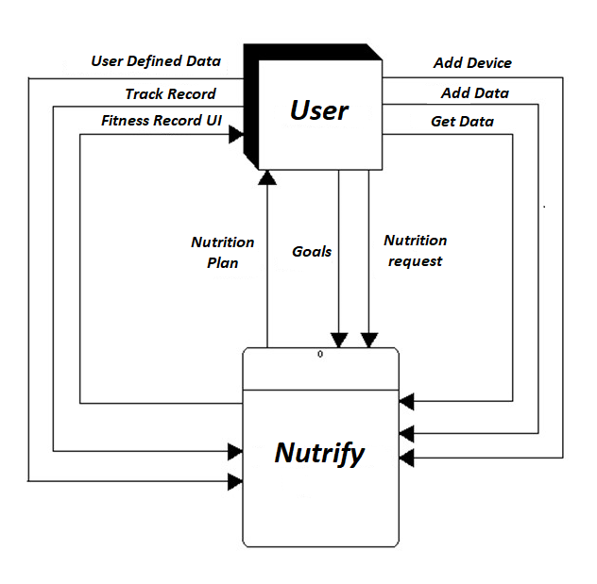

  - Use Case Diagram

User and Fitness App:

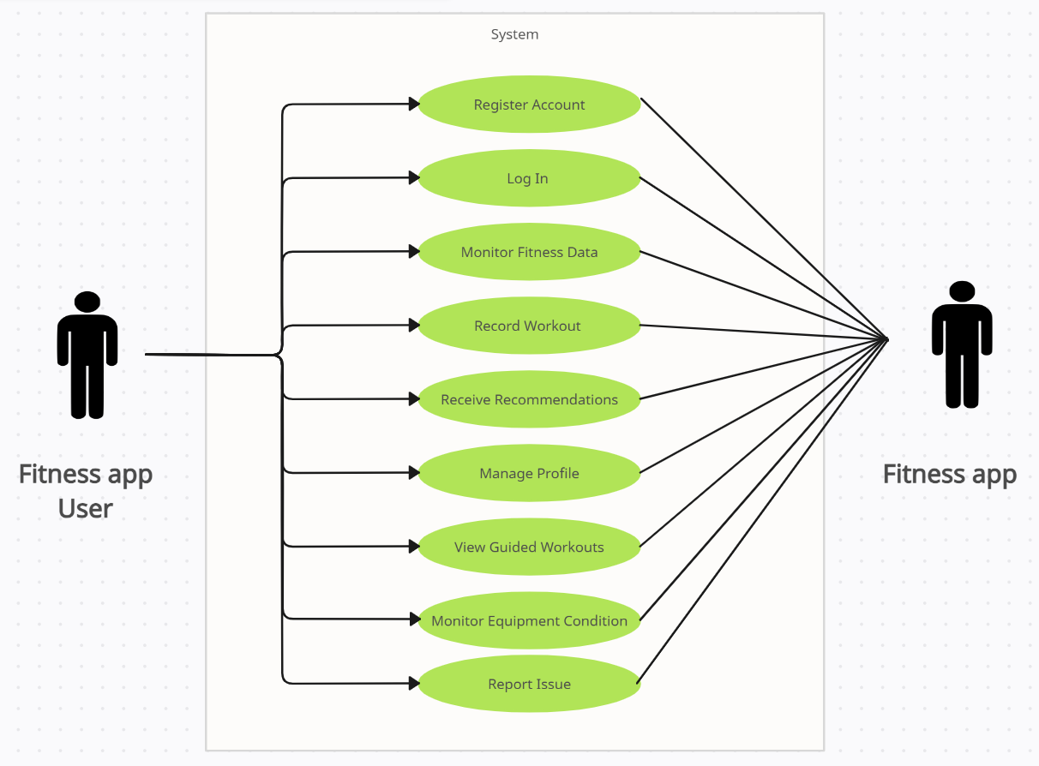

Android App and Digital Watch:

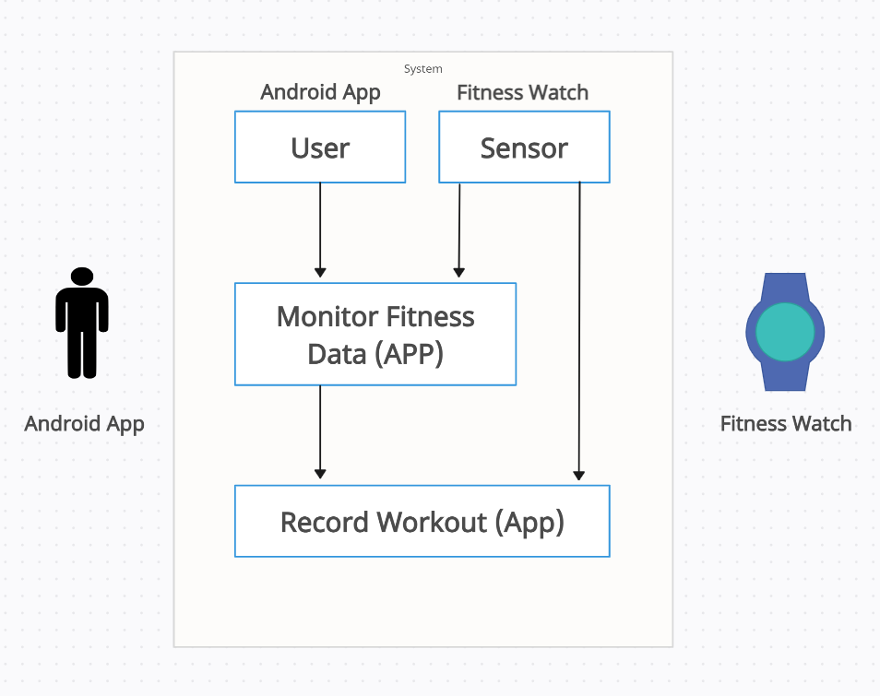

- Implementation

Let's consider a hypothetical example to perform the operations and explain the theory, calculations, and explanations involved in analyzing fitness input data using a machine learning algorithm. We'll divide the explanation into sections: Input Data Table, Machine Learning Algorithm Calculations, Gradient Descent Algorithm for Comparison, and Linear and Logistic Regression for Graph Presentation.

1. Input Data Table

The input data for our analysis consists of fitness-related data points from multiple users. In this example, we will use the following columns:

Age: User's age (e.g., 30, 25, 45).
Gender: User's gender (e.g., Male, Female).
Height: User's height in centimeters (e.g., 170, 160, 180).
Weight: User's weight in kilograms (e.g., 70, 65, 80).
Fitness Goals: User's fitness goals (e.g., Weight Loss, Muscle Building, Endurance Training).
Exercise Frequency: Number of times user exercises per week (e.g., 3, 4, 5).
Sleep Hours: Average number of hours user sleeps per night (e.g., 7, 6, 8).

Here is an example input data table:

Age | Gender | Height | Weight | Fitness Goals | Exercise Frequency | Sleep Hours
30 | Male | 170 | 70 | Weight Loss | 3 | 7
25 | Female | 160 | 65 | Muscle Building | 4 | 6
45 | Male | 180 | 80 | Endurance Training | 5 | 8

To provide calculations for the Gradient Descent algorithm and to draw graphs for Linear and Logistic Regression, let's consider a hypothetical fitness input example and apply these techniques.

Example Data

Let's start with a simplified example using the input data from our fitness-related data points:

Age | Gender | Height (cm) | Weight (kg) | Fitness Goals | Exercise Frequency (times/week) | Sleep Hours
30 | Male | 170 | 70 | Weight Loss | 3 | 7
25 | Female | 160 | 65 | Muscle Building | 4 | 6
45 | Male | 180 | 80 | Endurance Training | 5 | 8

Gradient Descent Algorithm

Gradient descent is an optimization algorithm that adjusts the model parameters (weights) to minimize the cost function. Let's apply it to linear regression.

1. Objective Function:

For linear regression, the objective is to minimize the mean squared error (MSE) between the predicted and actual fitness progress. The cost function can be defined as:

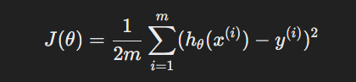

Where:
- ( m ) is the number of data points.
- ( h_theta(x^{(i)}) \) is the predicted value for data point ( i ).
- ( y^{(i)} ) is the actual value for data point ( i ).

The predicted value ( h_theta(x) ) is calculated using the linear regression model:

2. Gradient Descent Update Rule:

Gradient descent updates the model parameters iteratively to minimize the cost function:

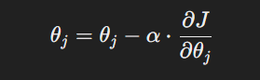
Where:
- \( \theta_j \) is the model parameter to be updated.
- \( \alpha \) is the learning rate (a small constant).
- \( \frac{\partial J}{\partial \theta_j} \) is the partial derivative of the cost function with respect to \( \theta_j \).

The partial derivatives for each parameter are calculated as:

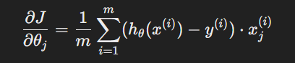

To provide a point table for Linear and Logistic Regression, let's consider the same hypothetical fitness input example:

Age | Gender | Height (cm) | Weight (kg) | Fitness Goals | Exercise Frequency (times/week) | Sleep Hours | Fitness Progress
30 | Male | 170 | 70 | Weight Loss | 3 | 7 | 15%
25 | Female | 160 | 65 | Muscle Building | 4 | 6 | 20%
45 | Male | 180 | 80 | Endurance Training | 5 | 8 | 10%

In the above table, "Fitness Progress" represents the observed or actual fitness progress of each individual in the example data. This data will be used as the dependent variable (y) in the regression models.

Linear Regression Point Table

In Linear Regression, the aim is to predict fitness progress (y) using a linear equation based on the input features. The equation can be represented as:

The following table represents the predicted fitness progress using linear regression and actual fitness progress (used for comparison):

Age | Gender | Height (cm) | Weight (kg) | Exercise Frequency | Sleep Hours | Predicted Fitness Progress | Actual Fitness Progress
30 | Male | 170 | 70 | 3 | 7 | Predicted Value | 15%
25 | Female | 160 | 65 | 4 | 6 | Predicted Value | 20%
45 | Male | 180 | 80 | 5 | 8 | Predicted Value | 10%

In the above table, "Predicted Fitness Progress" is calculated using the linear regression equation with weights (\(\theta_0, \theta_1, \theta_2, \theta_3, \theta_4, \theta_5\)) obtained from training the model.

Logistic Regression Point Table

In Logistic Regression, the aim is to classify the fitness progress into categories such as "Low," "Medium," or "High" based on a logistic (sigmoid) function:

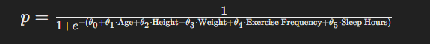

Where:
- \( p \) is the predicted probability of the class being "High" fitness level.
- The decision boundary is typically set at 0.5 for classification.

The following table represents the predicted probability and predicted class using logistic regression:

Age | Gender | Height (cm) | Weight (kg) | Exercise Frequency | Sleep Hours | Predicted Probability | Predicted Class
30 | Male | 170 | 70 | 3 | 7 | Probability | Low/Medium/High
25 | Female | 160 | 65 | 4 | 6 | Probability | Low/Medium/High
45 | Male | 180 | 80 | 5 | 8 | Probability | Low/Medium/High

The "Predicted Probability" is calculated using the logistic function, and the predicted class is derived based on the decision boundary (e.g., if the probability is above 0.5, the class is "High" fitness level).

- Output
Login Screen:

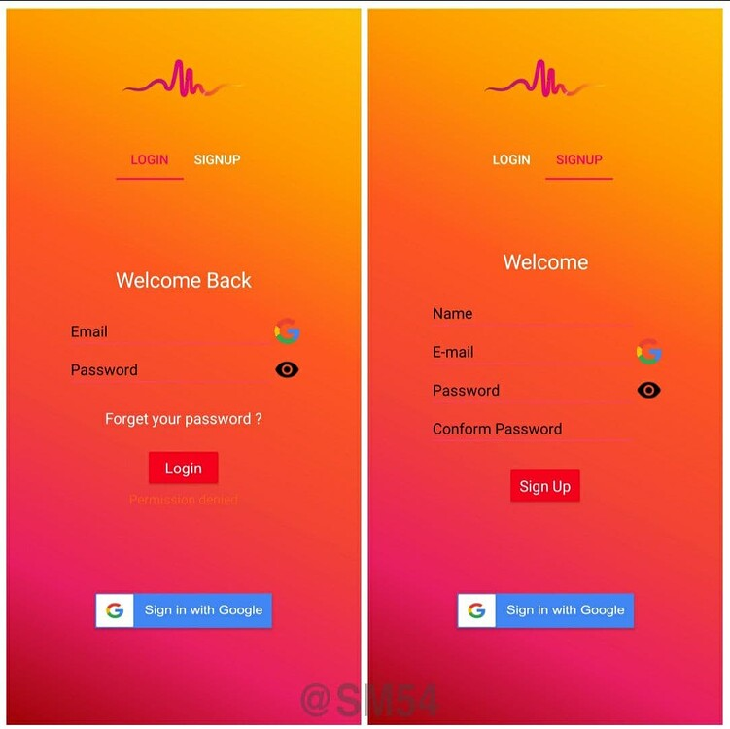

Home Page/Landing Page:
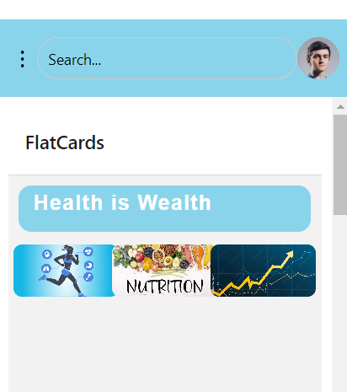

Navbar/heading:



Tracking:
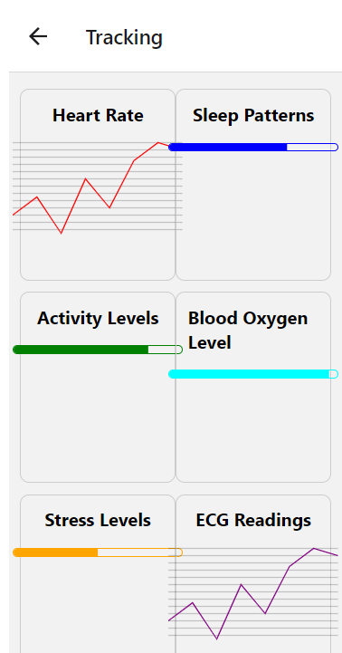

Nutrition:
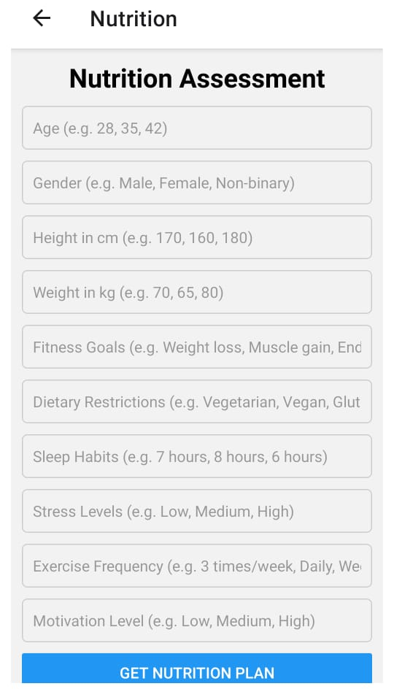

Progress Screen:

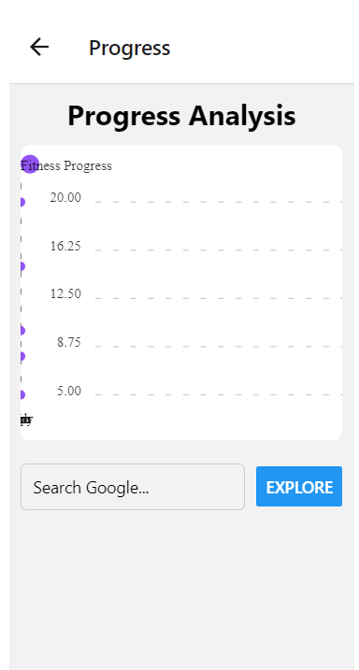

- Conclusion

In conclusion, the fusion of Android fitness apps with IoT data collection and machine learning for fitness analysis and goal prediction holds great promise but also encounters critical challenges. While these innovations offer real-time monitoring, tailored guidance, and data-driven insights, data privacy and security are paramount concerns. Ensuring data accuracy, device compatibility, and sustained user engagement are crucial. Moreover, as user behavior and goals evolve, the need for adaptive machine learning models becomes apparent. Addressing these challenges effectively can unlock the potential of these technologies, revolutionizing health and fitness management, and empowering users to make informed decisions on their journey toward improved well-being.

- Future Scope
The future for the "Nutrify" app in the health and nutrition industry holds immense promise. As the demand for personalized health solutions continues to grow, Nutrify tailored workout plans, real-time monitoring, and intelligent recommendations align perfectly with evolving user needs. By fostering user engagement, partnerships, and research collaborations, the app is poised to make significant contributions to improving health outcomes, influencing behavior change, and shaping the landscape of modern health and nutrition applications.

- References:

1]R. Mou and J. Yang, "Design and Implementation of Mobile APP for Athletes' Physical Fitness Monitoring During Training," 2021 13th International Conference on Measuring Technology and Mechatronics Automation (ICMTMA), Beihai, China, 2021, pp. 678-681, doi: 10.1109/ICMTMA52658.2021.00156.

2]S. Khosla, D. Malla, I. Dua, D. Bura and P. Chawla, "“Nutri-Mental” ─An Android Application For Personal Health And Nutrition Management," 2020 5th International Conference on Communication and Electronics Systems (ICCES), Coimbatore, India, 2020, pp. 1288-1292, doi: 10.1109/ICCES48766.2020.9137890.

3]Kheirkhahan, Matin & Nair, Sanjay & Davoudi, Anis & Rashidi, Parisa & Wanigatunga, Amal & Corbett, Duane & Mendoza, Tonatiuh & Manini, Todd & Ranka, Sanjay. (2018). A Smartwatch-Based Framework for Real-Time and Online Assessment and Mobility Monitoring. Journal of Biomedical Informatics. 89. 10.1016/j.jbi.2018.11.003.

4]Shaohai Jiang, Lianshan Zhang & Kevin Teo (2021) Social Use of Fitness Apps and Physical Activity Knowledge: The Roles of Information Elaboration and Interpersonal Communication, Journal of Broadcasting & Electronic Media, 65:4, 549-574, DOI: 10.1080/08838151.2021.1990295

5] Wu, Lin. (2021). Scientific Impact of Sports on Human Health and Physique Based on Optimization Big Data Ant Colony Algorithm. Wireless Communications and Mobile Computing. 2021. 10.1155/2021/2456629.

6] Kim B, Lee E. What Factors Affect a User's Intention to Use Fitness Applications? The Moderating Effect of Health Status: A Cross-Sectional Study. Inquiry. 2022 Jan-Dec;59:469580221095826. doi: 10.1177/00469580221095826. PMID: 35580021; PMCID: PMC9118403.

7] Tavares, Bruno & Pires, Ivan & Marques, Gonçalo & Garcia, Nuno & Zdravevski, Eftim & Lameski, Petre & Trajkovik, Vladimir & Jevremovic, Aleksandar. (2020). Mobile Applications for Training Plan Using Android Devices: A Systematic Review and a Taxonomy Proposal. Information. 11. 343. 10.3390/info11070343.

8] https://chat.openai.com

9] https://bard.google.com

10] https://www.healthline.com

